SPH3U Motion Graph Exploration with SparkVue & Wireless Carts Name:______

**Learning Goal:** To develop an understanding of the motion graph shapes (position-time, velocity-time and acceleration-time) associated with motion in one dimension.

**Success Criteria:**

-I can identify motion as uniform or accelerated.

I can sketch the graphs associated with uniform motion in one dimension.

I can sketch the graphs associated with accelerated motion in one dimension.

**Materials**: ramp, wireless cart, Ipad with Sparkvue

Instructions: Setting up the Sparkvue Interface

1. Obtain a Wireless cart and turn it on by pressing the power button ( ) on the side.
2. Open Sparkvue on the Ipad and click the BlueTooth icon ( ) to connect with your cart. Check that your cart is connected!
3. Click on the HOME ( ) button and choose Build.
4. Click on Position- you will see a Position-Time Graph appear.
5. Click on the Add Graph ( ) icon on the bottom of the screen TWO times to create two new graphs.
6. For the middle graph Click on the SELECT MEASUREMENT label on the Y-axis and choose VELOCITY. For the bottom graph, click on SELECT MEASUREMENT label and choose ACCELERATION.

You will now have a screen that looks like the image below.

You can adjust the horizontal time scale by using two fingers to expand and contract the view FOR ALL THREE graphs.

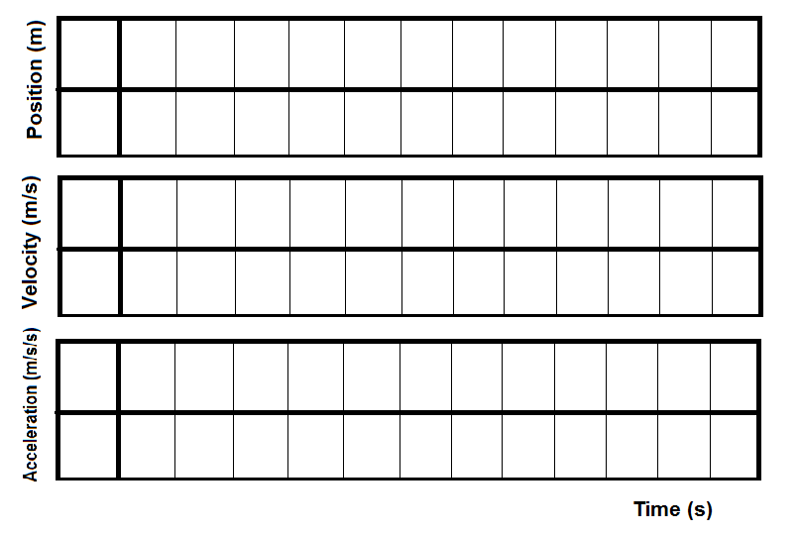 You can use two fingers to expand or contract the vertical scale for each graph INDIVIDUALLY.

**Activities:**

1. **Testing your cart**:

Hit the GREEN PLAY ( ) button to start collecting data.

 Leave the cart at rest for a moment and then push the cart back and forth. Make sure you can see the motion on the recorded graphs. Hit the STOP button when done. ( ).



Hit the Experiment Tools Icon ( ) and select **Manage Data**. .Select **Delete Last Run** to clear the data set. Hit OK and DONE.



Click on the Sampling Icon (Periodic: 20 Hz ) and increase the sample rate to 50 Hz.

1. **VELOCITY FORWARD AND BACKWARD**:

Move the cart at a constant SLOW VELOCITY FORWARD, STOP IT FOR A FEW MOMENTS, then move the cart at FAST VELOCITY BACKWARD.

Repeat this motion several times until you get a clean graph.

Sketch the graph shapes. Include time units and the y-axis limits on each graph.

Describe each phase of the motion you can see on the graphs:

1. **CONSTANT VELOCITY AND SUDDEN STOP**:

Place the cart on a smooth surface and place a large book or backpack about 1.0 m away from the cart.

Give the cart a strong push and let it roll away until it is stopped by the obstacle.

Repeat this motion several times until you get a clean graph. Expand the graphs horizontally and vertically until you can clearly see the details of the motion.

Sketch the expanded graph shapes. Include time units and the y-axis limits on each graph.

Try and identify the following three phases of motion:

Phase 1-your initial push to get the cart moving

Phase 2- the region where the cart was moving at a constant velocity

Phase 3- the region where the cart was stopped by the obstacle.

Label each region on the three graphs.

Discuss the graph shapes when the cart is moving at a constant velocity.

1. **ROLLING DOWN A RAMP**

Place the cart at the top of the ramp and let it roll down. Sketch the graphs produced.

What kind of motion is this (constant velocity or accelerated)? How do you know?

1. **ROLLING UP A RAMP**

Place the cart at the BOTTOM of the ramp and give it a push so that it rolls up to a stop.

 Sketch the graphs produced.

What kind of motion is this (constant velocity or accelerated)? How do you know?